TSD PRACTICAL NO – 1
NAME -SIONA MARY BABU (5th SEM IT)
UID- 24010010
AIM- To design a Responsive Restaurant Landing Page.
CODE
INDEX.HTML
<!DOCTYPE html>
<html lang="en">
<head>
<meta charset="UTF-8">
<meta name="viewport"
content="width=device-width, initial-scale=1.0">
<title>Tasty Bites Restaurant</title>
<!-- Google Fonts -->
<link rel="preconnect"
href="https://fonts.googleapis.com">
<link rel="preconnect"
href="https://fonts.gstatic.com"
crossorigin>
<link href="https://fonts.googleapis.com/css2?family=Poppins:wght@300;400;500;600;700&family=Playfair+Display:wght@700&display=swap"
rel="stylesheet">
<!-- Font Awesome -->
<link rel="stylesheet"
href="https://cdnjs.cloudflare.com/ajax/libs/font-awesome/6.5.2/css/all.min.css">
<link rel="stylesheet"
href="style.css">
</head>
<body>
<!--NAVBAR-->
<header>
<nav class="navbar">
<div class="logo">
Tasty <span>Bites</span>
</div>
<input type="checkbox" id="menu">
<label for="menu" class="menu-icon">
<i class="fa-solid fa-bars"></i>
</label>
<ul class="nav-links">
<li><a href="#menu-section">Menu</a></li>
<li><a href="#about">About</a></li>
<li><a href="#gallery">Gallery</a></li>
<li><a href="#reviews">Reviews</a></li>
<li><a href="#contact">Contact</a></li>
<li>
<a href="#contact"
class="book-btn">
Book Table
</a>
</li>
</ul>
</nav>
</header>
<!--HERO -->
<section class="hero"
id="home">
<div class="hero-text">
<h1>
Taste the Best Food in Town
</h1>
<p>
Welcome to Tasty Bites where delicious flavors,
premium ingredients, and unforgettable dining
experiences come together.
</p>
<div class="hero-buttons">
<a href="#menu-section"class="btn">Order Now</a>
<a href="#gallery"class="btn outline">Explore Menu</a>
</div>
</div>
</section>
<!--POPULAR DISHES -->
<section class="dishes"
id="menu-section">
<h2 class="section-title">
Popular Dishes
</h2>
<div class="dish-grid">
<!-- Card 1 -->
<div class="dish-card"> <img src="images/pizza.jpg">
<h3>Margherita Pizza</h3>
<p>Crispy crust with mozzarella cheese.</p>
<div class="price"> ₹259</div>
<div class="rating">
⭐⭐⭐⭐
</div>
<button> Order Now</button> </div>
<!-- Card 2 -->
<div class="dish-card"> <img src="images/burger.jpg">
<h3>Veg Burger</h3>
<p> Loaded with fresh veggies & cheese.</p>
<div class="price"> ₹170 </div>
<div class="rating">
⭐⭐⭐⭐⭐
</div>
<button>Order Now</button>
</div>
<!-- Card 3 -->
<div class="dish-card"> <img src="images/biryani.jpg">
<h3>Chicken Biryani</h3>
<p> Aromatic rice with juicy chicken. </p>
<div class="price">₹349
</div>
<div class="rating">
⭐⭐⭐⭐⭐
</div>
<button> Order Now </button>
</div>
<!-- Card 4 -->
<div class="dish-card"> <img src="images/pasta.jpg">
<h3>Pasta Alfredo</h3>
<p> Creamy white sauce Italian pasta.</p>
<div class="price">
₹269
</div>
<div class="rating">
⭐⭐⭐⭐⭐
</div>
<button> Order Now </button>
</div>
<!-- Card 5 -->
<div class="dish-card"> <img src="images/paneer.jpg">
<h3>Paneer Tikka</h3>
<p>Smoky grilled paneer cubes. </p>
<div class="price">₹259
</div>
<div class="rating">
⭐⭐⭐⭐⭐
</div>
<button> Order Now
</button>
</div>
<!-- Card 6 -->
<div class="dish-card"><img src="images/sandwich.jpg">
<h3>Grilled Sandwich</h3>
<p> Crispy sandwich with fresh veggies. </p>
<div class="price">
₹149
</div>
<div class="rating">
⭐⭐⭐⭐
</div>
<button> Order Now
</button>
</div>
<!-- Card 7 -->
<div class="dish-card">
<img src="images/cake.jpg">
<h3>Chocolate Cake</h3>
<p>
Rich chocolate delight.
</p>
<div class="price">
₹199
</div>
<div class="rating">
⭐⭐⭐⭐⭐
</div>
<button>
Order Now
</button>
</div>
<!-- Card 8 -->
<div class="dish-card">
<img src="images/juice.jpg">
<h3>Fresh Juice</h3>
<p>
Healthy seasonal fruit juice.
</p>
<div class="price">
₹109
</div>
<div class="rating">
⭐⭐⭐⭐⭐
</div>
<button>
Order Now
</button>
</div>
</div>
</section>
<!-- WHY CHOOSE US -->
<section class="features"
id="about">
<h2 class="section-title">
Why Choose Us
</h2>
<div class="feature-grid">
<div class="feature-card">
<i class="fa-solid fa-seedling"></i>
<h3>Fresh Ingredients</h3>
<p>Only premium quality ingredients.</p>
</div>
<div class="feature-card">
<i class="fa-solid fa-utensils"></i>
<h3>Expert Chefs</h3>
<p>Prepared by experienced chefs.</p>
</div>
<div class="feature-card">
<i class="fa-solid fa-truck-fast"></i>
<h3>Fast Delivery</h3>
<p>Quick delivery to your doorstep.</p>
</div>
<div class="feature-card">
<i class="fa-solid fa-award"></i>
<h3>Premium Quality</h3>
<p>Best taste with highest standards.</p>
</div>
</div>
</section>
<!--GALLERY-->
<section class="gallery" id="gallery">
<h2 class="section-title">
Food Gallery
</h2>
<div class="gallery-grid">
<div class="gallery-item">
<img src="images/sizzler.jpg" alt="Chicken Sizzler">
<div class="gallery-overlay">
<h3>Chicken Sizzler</h3>
</div>
</div>
<div class="gallery-item">
<img src="images/paneer-butter.jpg" alt="Paneer Butter Masala">
<div class="gallery-overlay">
<h3>Paneer Butter Masala</h3>
</div>
</div>
<div class="gallery-item">
<img src="images/noodles.jpg" alt="Hakka Noodles">
<div class="gallery-overlay">
<h3>Hakka Noodles</h3>
</div>
</div>
<div class="gallery-item">
<img src="images/thali.jpg" alt="Thali Platter">
<div class="gallery-overlay">
<h3>Thali Platter</h3>
</div>
</div>
<div class="gallery-item">
<img src="images/salad.jpg" alt="Salad">
<div class="gallery-overlay">
<h3>Salads</h3>
</div>
</div>
<div class="gallery-item">
<img src="images/mojito.jpg" alt="Mojito">
<div class="gallery-overlay">
<h3>Fresh Mojito</h3>
</div>
</div>
<div class="gallery-item">
<img src="images/icecream.jpg" alt="Ice Cream Sundae">
<div class="gallery-overlay">
<h3>Ice Cream Sundae</h3>
</div>
</div>
<div class="gallery-item">
<img src="images/pulao.jpeg" alt="Pulao">
<div class="gallery-overlay">
<h3>Pulao</h3>
</div>
</div>
<div class="gallery-item">
<img src="images/manchurian.jpg" alt="Manchurian">
<div class="gallery-overlay">
<h3>Manchurian</h3>
</div>
</div>
</div>
</section>
</div>
</section>
<!-- CUSTOMER REVIEWS -->
<section class="reviews" id="reviews">
<h2 class="section-title">
What Our Customers Say
</h2>
<div class="review-container">
<!-- Review 1 -->
<div class="review-card">
<img src="images/review.jpeg" alt="Customer">
<h3>Emily Johnson</h3>
<div class="stars">
⭐⭐⭐⭐⭐
</div>
<p> Amazing ambience and delicious food.
Definitely one of the best restaurants
I've visited!
</p>
</div>
<!-- Review 2 -->
<div class="review-card">
<img src="images/review2.jpeg" alt="Customer">
<h3>David Miller</h3>
<div class="stars">
⭐⭐⭐⭐⭐
</div>
<p>
Fast delivery, fresh ingredients,
and excellent customer service.
Highly recommended!
</p>
</div>
<!-- Review 3 -->
<div class="review-card">
<img src="images/review3.jpeg" alt="Customer">
<h3>Sophia Williams</h3>
<div class="stars">
⭐⭐⭐⭐⭐
</div>
<p>
Loved the pasta and desserts.
Beautiful interior and wonderful staff.
</p>
</div>
</div>
</section>
<!-- CONTACT-->
<section class="contact" id="contact">
<h2 class="section-title">
Contact Us
</h2>
<div class="contact-container">
<!-- Left Side -->
<div class="contact-info">
<h3>Visit Tasty Bites</h3>
<p>
<i class="fa-solid fa-location-dot"></i>
123 Food Street,
Mumbai, India
</p>
<p>
<i class="fa-solid fa-phone"></i>
+91 9876543210
</p>
<p>
<i class="fa-solid fa-envelope"></i>
tastybites@gmail.com
</p>
<p>
<i class="fa-solid fa-clock"></i>
Mon - Sun : 10:00 AM - 11:00 PM
</p>
</div>
<!-- Contact Form -->
<form class="contact-form">
<input
type="text"
placeholder="Your Name"
required>
<input
type="email"
placeholder="Your Email"
required>
<textarea
rows="6"
placeholder="Your Message"
required>
</textarea>
<button type="submit">
Submit
</button>
</form>
</div>
</section>
<!-- FOOTER -->
<footer>
<div class="footer-container">
<div class="footer-logo">
<h2>
Tasty <span>Bites</span>
</h2>
<p>
Bringing delicious food
and unforgettable dining
experiences every day.
</p>
</div>
<div class="footer-links">
<h3>Quick Links</h3>
<ul>
<li><a href="#home">Home</a></li>
<li><a href="#menu-section">Menu</a></li>
<li><a href="#gallery">Gallery</a></li>
<li><a href="#reviews">Reviews</a></li>
<li><a href="#contact">Contact</a></li>
</ul>
</div>
<div class="footer-social">
<h3>Follow Us</h3>
<div class="social-icons">
<a href="#">
<i class="fab fa-facebook-f"></i>
</a>
<a href="#">
<i class="fab fa-instagram"></i>
</a>
<a href="#">
<i class="fab fa-twitter"></i>
</a>
<a href="#">
<i class="fab fa-youtube"></i>
</a>
</div>
</div>
</div>
<hr>
<p class="copyright">
© 2026 Tasty Bites.
All Rights Reserved.
</p>
</footer>
</body> </html>
SCREENSHOT
MENU
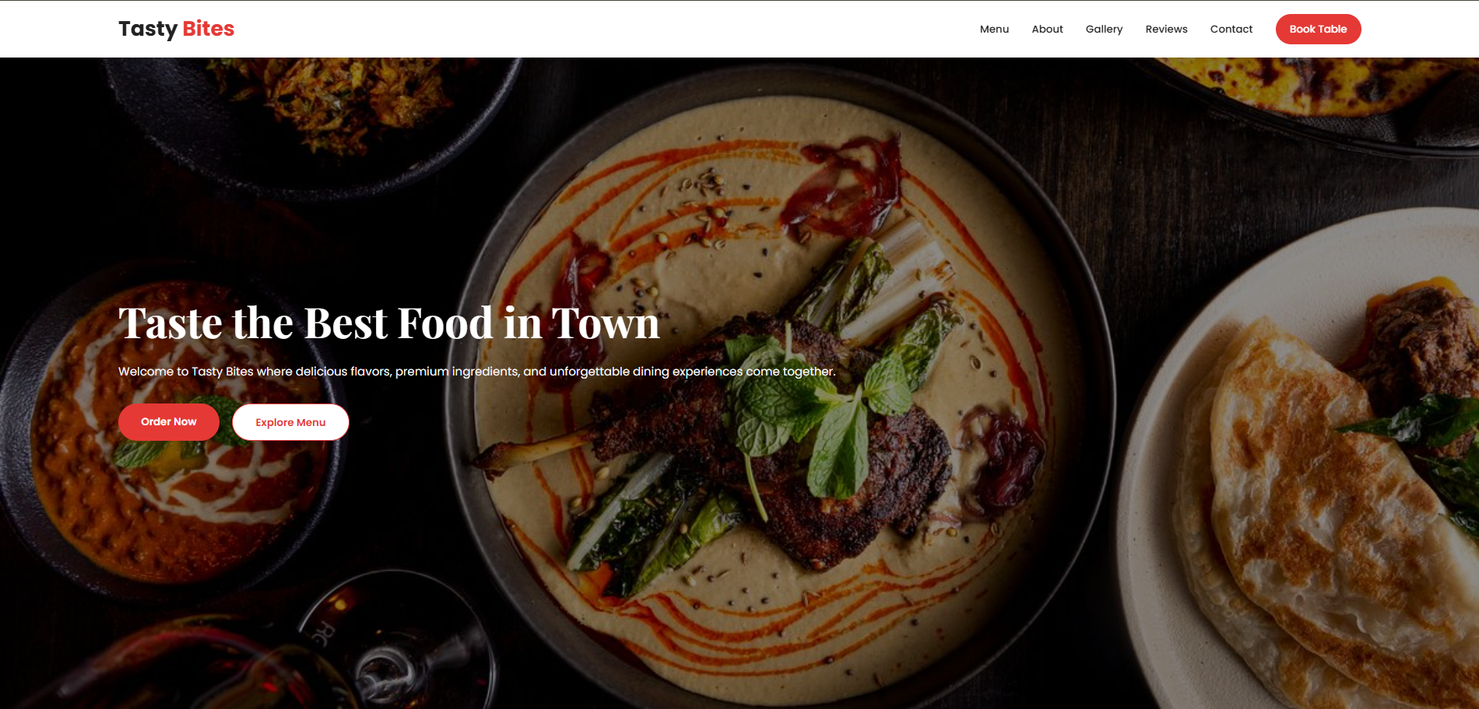
DISHES 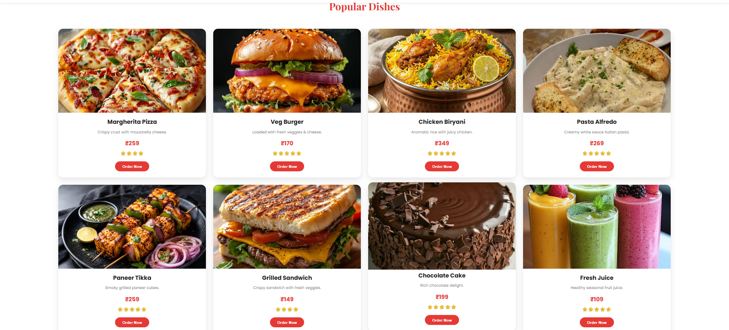
ABOUT
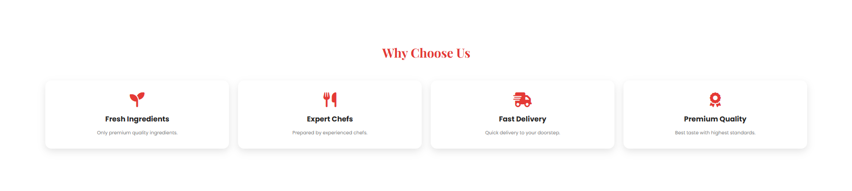
GALLERY
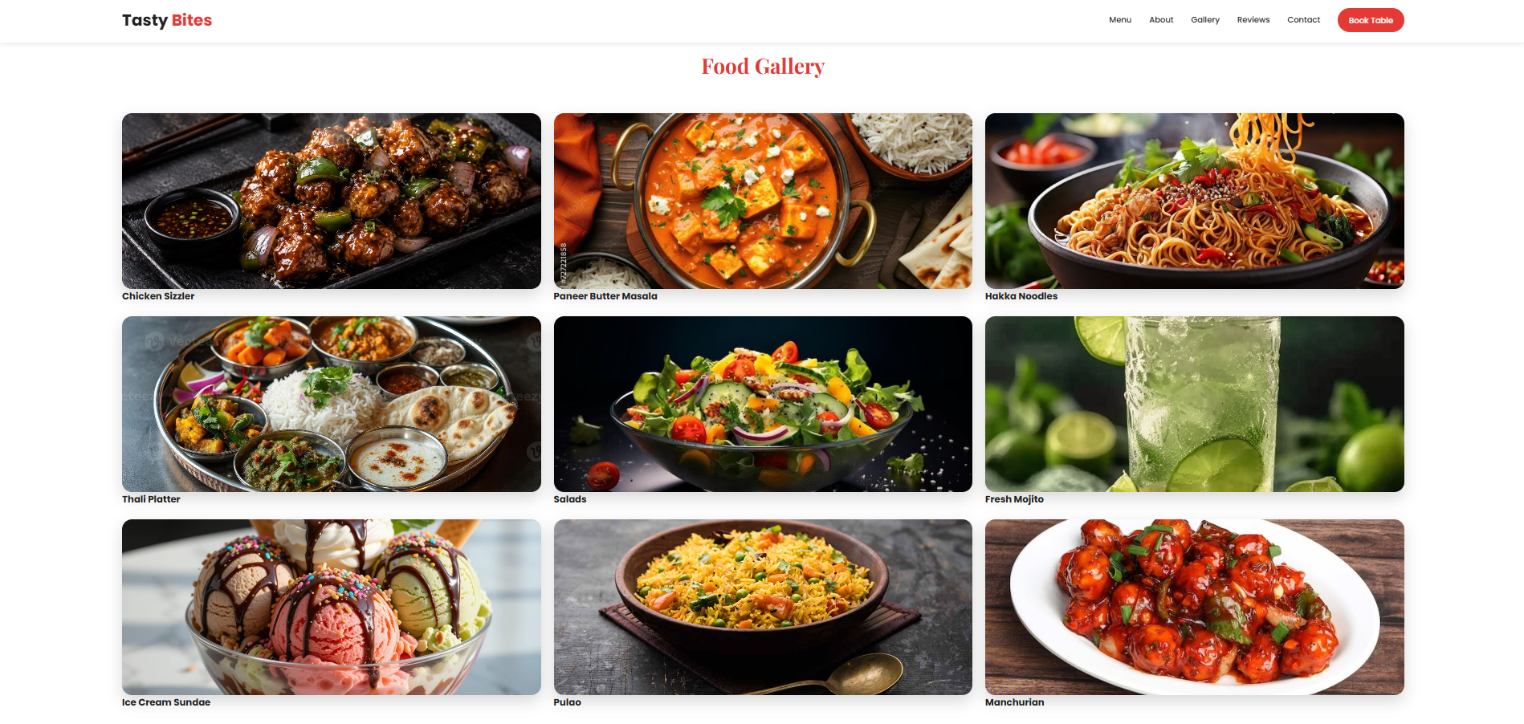
REVIEWS
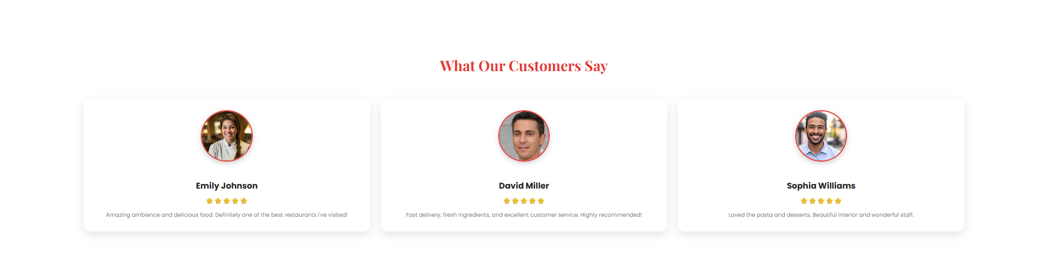
CONTACT
